**Task 1**

**Introduction**

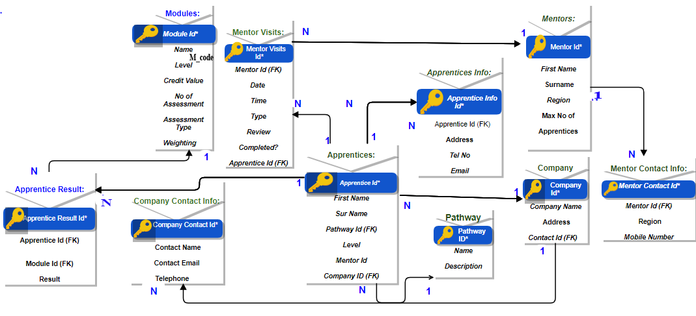Our live are run and dictate by data. Data define us. It is the single most important in our world of this age. Complete countries can be run and down by use/misuse of data. So we need ways to, nicely, store/access data. Databases are the tool we use to achieve the goal of nice use/storage of data. Collier’s Apprenticeship system, till now use, paper to manage their records. Now they can use database and it will be more efficient and easy. It is a necessary.

Figure 1: the most important part of this assignment ERD.

**B) Entity relationship diagram with full normalization this assignment.**

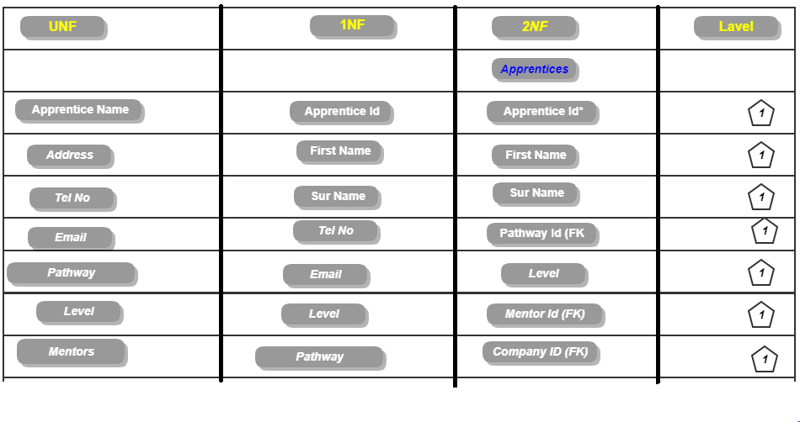

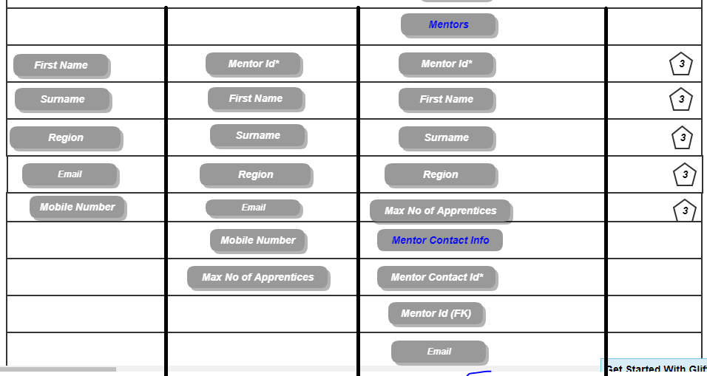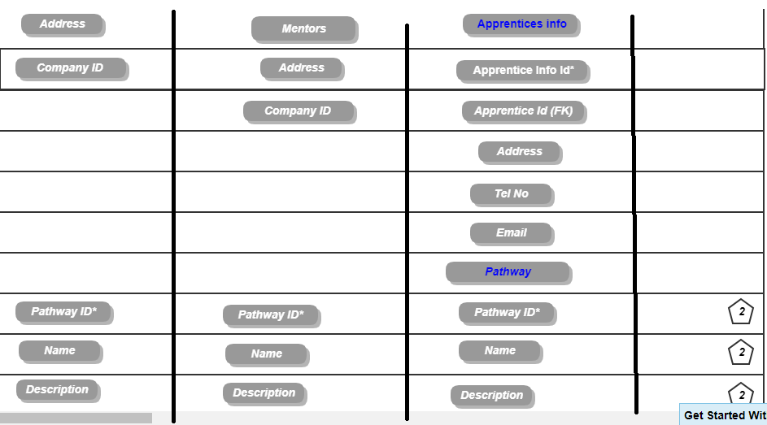

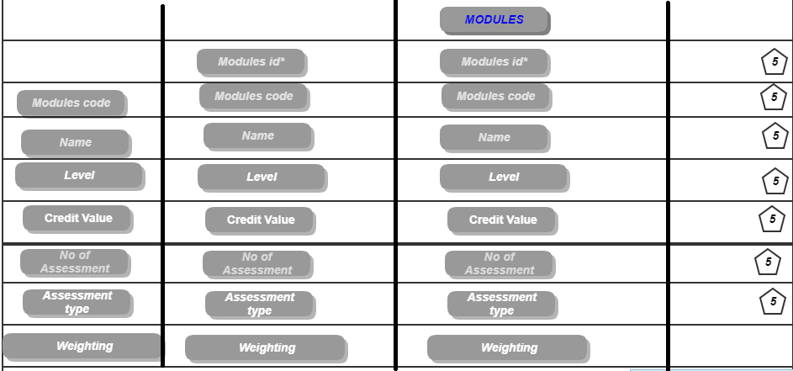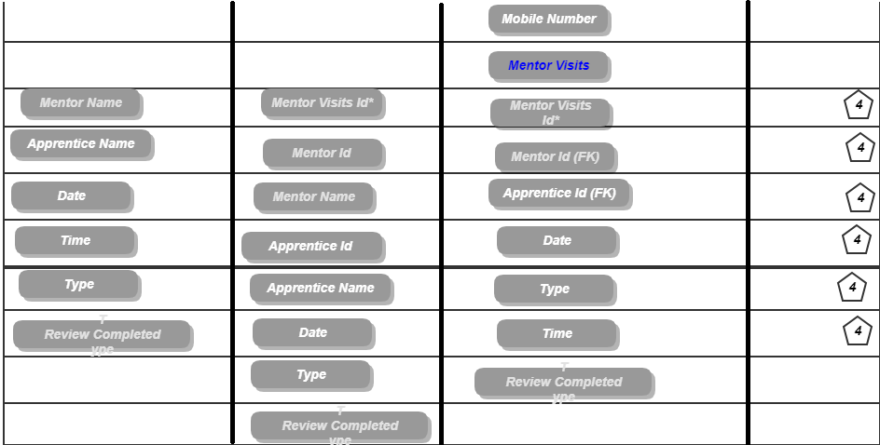

**Discussion of ERD**:

**Apprentices**: This table is the mother table because it has all the ERD relation with it, there is a few columns inside it, such as First Name, surname, pathway, Level, and Company ID. But inside it is a primary key and two foreign ones are sent by ID and Company ID, these are basically foreign keys.

**Pathway**: There are three attributes in the pathway table, such as pathway id, name, and description. This table basically creates a relationship with the apprentice table, with name ID and the discretion visible. Pathway ID will be used primarily as a primary key in this table.

**Company**: The Company's main work is the company name address and company's contact ID database created company ID has a foreign key. apprentices table is linked to the company, and another relationships with the company contact info have been created.

**Company contact info:** Company Contact Info Table is basically the only link to the company table. Links to any other table are not attributable to the company contact info contact name email and telephone number. This id has no foreign key but there is a primary key here. Email and telephone numbers can be given at the following.

**Apprentice result:** The problem was to get more trouble in making this table because I started creating data tables without relation with foreign keys, but first we have to create primary key for foreign key relation. Apprentice Result table basically creates relation with two tables, one is the Apprentices table, and the other is the module table affinity test table, which contains two foreign keys and a result attribute showing results found in the result table and creating relationships with two foreign keys.

**Modules**: There was no problem in creating the module table because the data table here was initially created and inserted as an attribute number and a primary key created in this table's attributes are the Level, Number of Assessment, Assessment type and Weighting. And there was no foreign key in this table and no need to create a relationship.

**Mentor visit:** This table basically contains all the information about mentor visits and it is indicated by attributes that require some information from the mentor, the database has been created with the help of inserts so that the data can be easily seen. This table has created relationships with the mentor table and here are two foreign keys for making relationships.

**Mentor**: All information is easily available through the Mentor table, and this table has been created to link the table of visit table where the mentor is located on this table and its e-mail address is provided. There was no error in dealing with this error when creating this table.

**Mentor contact info:** The mentor contact info table, usually working as a sub table of mentor detectives, is given to this table to give NCC RECOMMANNATION fulfill so that users do not have trouble finding it and if there is a lot of data inside a table, the table's beauty stops, so that The table has been created**.**

**Apprentice info:** In order to create a database management system, special rules are to be made, but in the case of data reliability, some things have to be added, thus enhancing the beauty of the database management system. Here the apprentice sub-table is the apprentice info.

**c. Data dictionary** 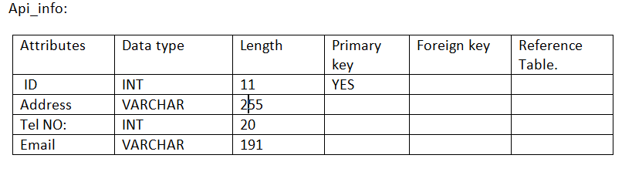

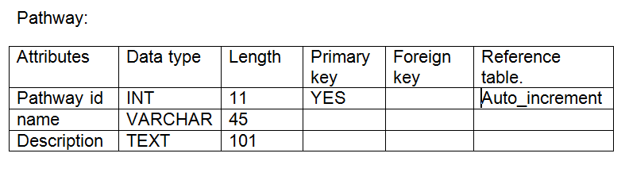

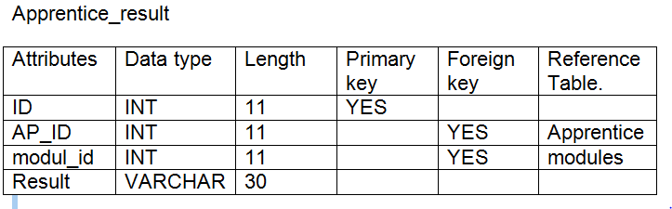

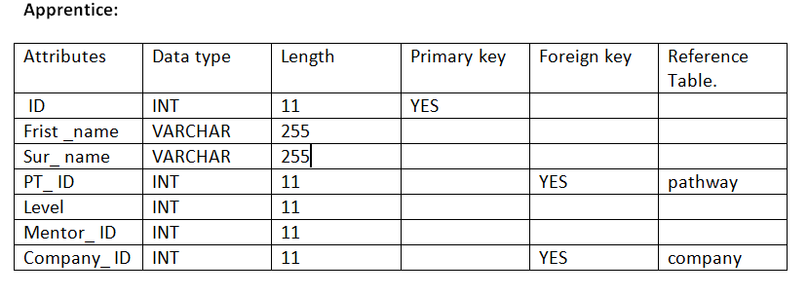

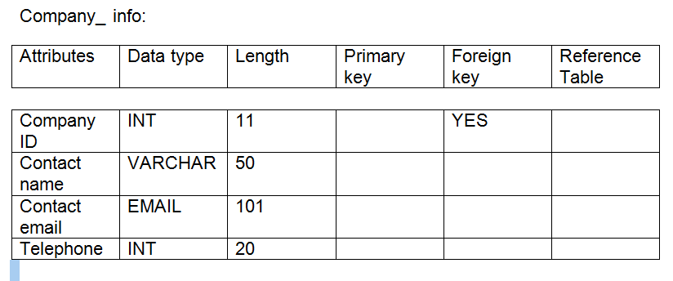

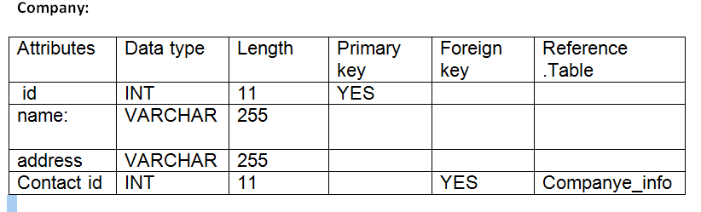

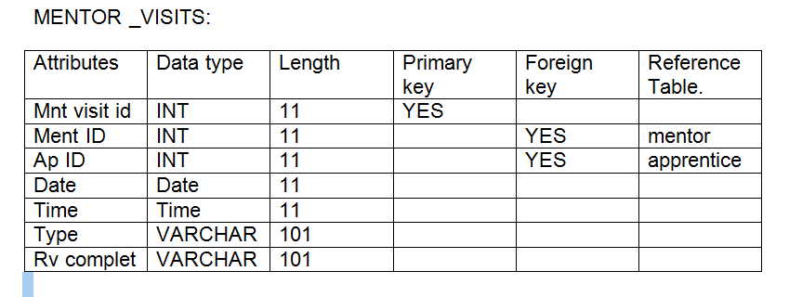

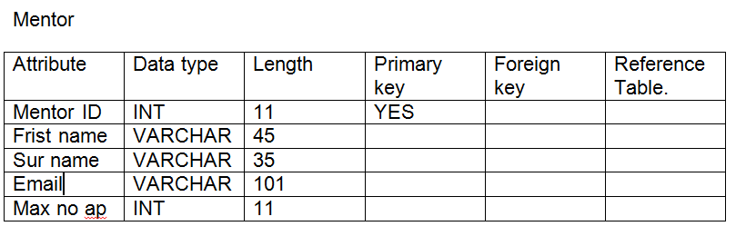

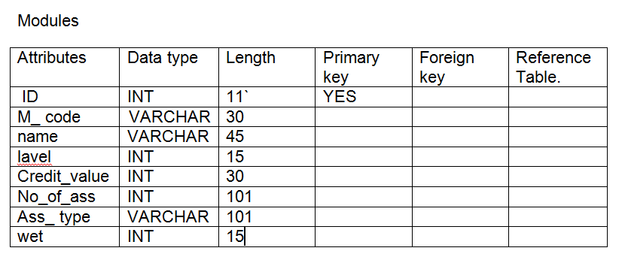

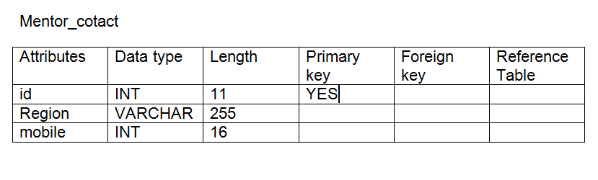

**Task 2**

**Login xampp server and open with cmd folder. And create databases.**

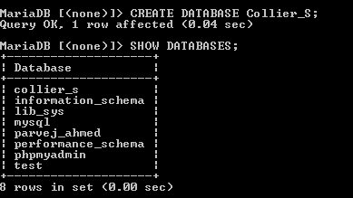Figure 1: create databases name with collier

**Pathway table**

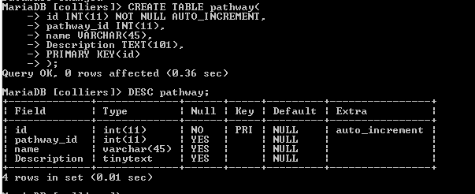

Figure 2: create with pathway table.

**Mentor table**

Figure 3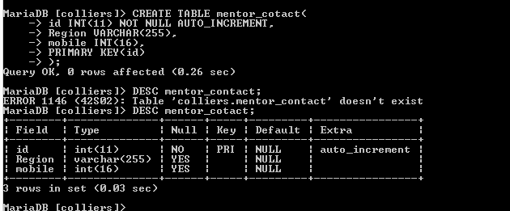:create with mentor table.

**Modules table**

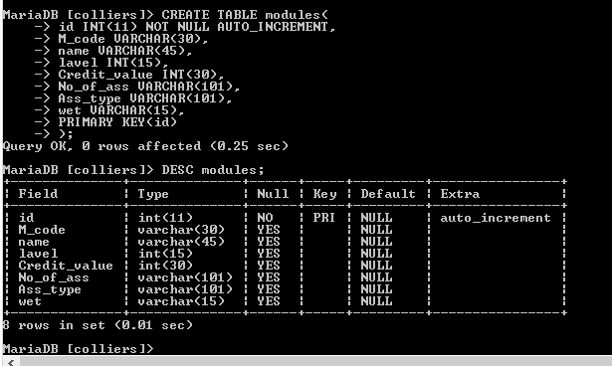  
Figure 4:this is a modules tables.

**Company _info table.**

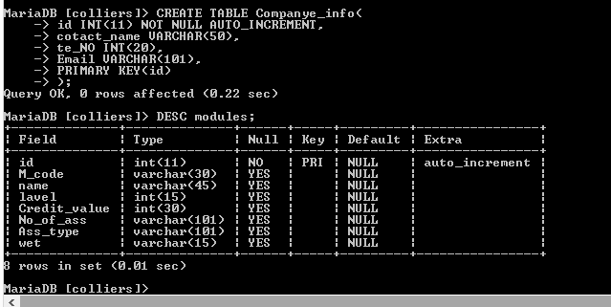

Figure 5: create with this companye_info.

**Company table.**

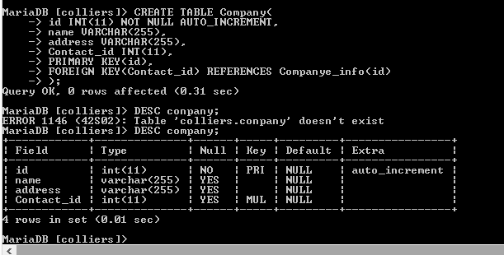

Figure 6: company databases table.

**Mentor table:**

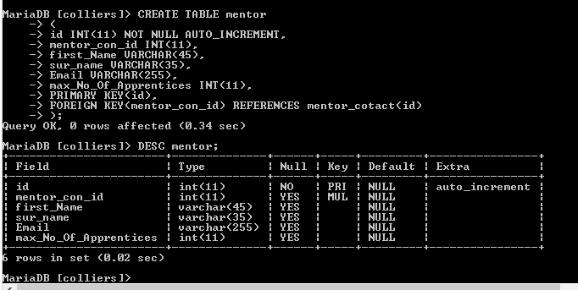

Figure 7:create table mentor.

**Api _info:**

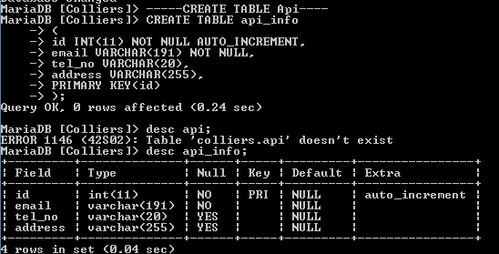

Figure 8api_info means apprentice info.

**Apprentice table:**

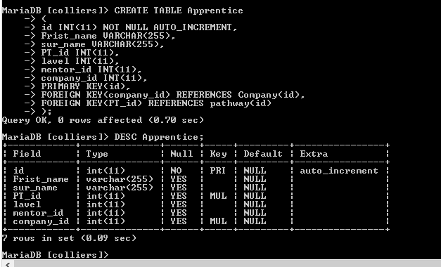

Figure 9:it is apprentice table databases.

**Apprentice_result:**

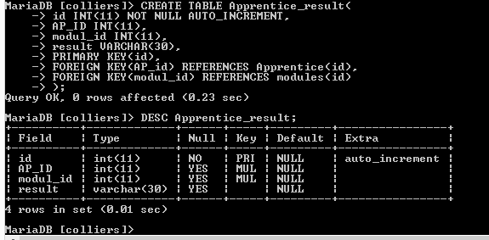

Figure 10: apprientice_result table with databases.

**Mentor visitor table:**

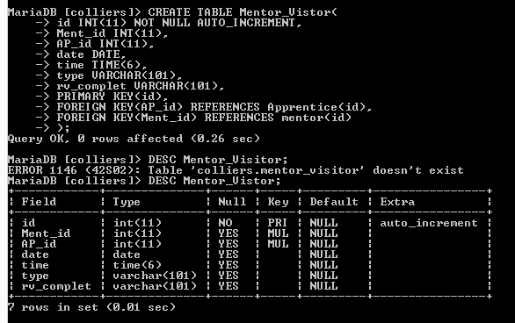

Figure 11: it is mentor_visitor databases table.

**2 B) Enter all data on apprentices and pathways.**

**Insert Apprentice**:

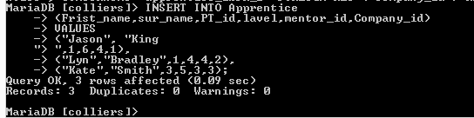

Figure 12:insert into data with apprentices

**Pathway**

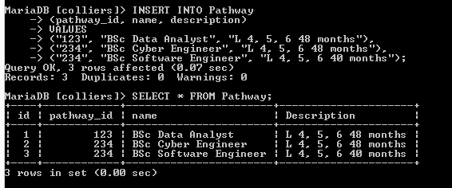

Figure 13: insert into pathway table.

**3.enter all data mentor:**

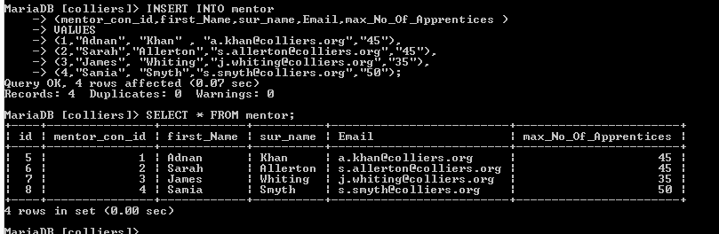

Figure 14:insert data table with mentor.

**4.enter models data:**

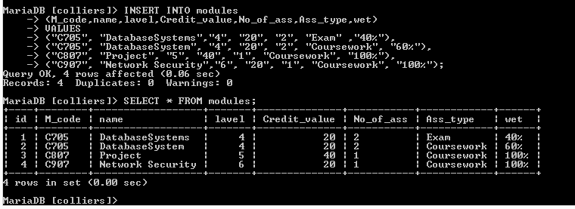

Figure 15:insert into modules data.

**5. Apprentice result.**

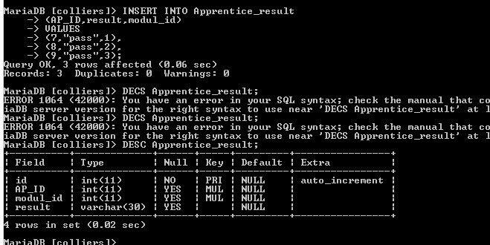

Figure 16: insert with data table apprentice result.

**6. Mentor visit**

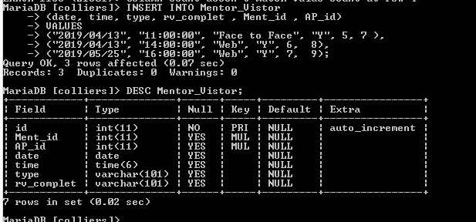

Figure 17: insert into mentor visit.

**7. companye data.**

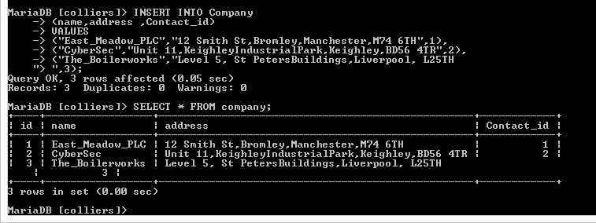

Figure 18:insert into company data table.

**8. Apprentice and pathway alphabetically first and surname order by order.**

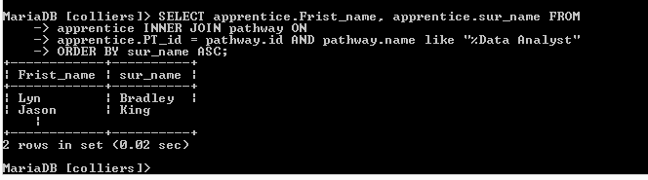

Figure 19: apprentice and pathway first name, surname order by order

9. Apprentice first name and surname pass list..

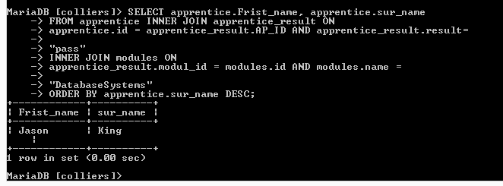.Figure 20: order by order apprentice first and surname pass.

**10. samia Smyth.**

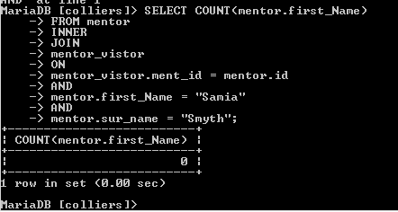

Figure 21: counts all the visit first name and surname.

**11. Returns mentors first surname, region, and email.**

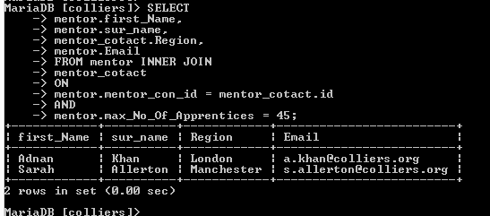

Figure 22: returns into mentors first surname, email.

**12. Select for all modules data.**

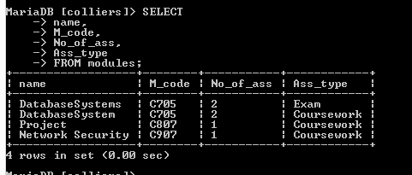

Figure 23: select from all data modules table.

**13. Insert a new modules.**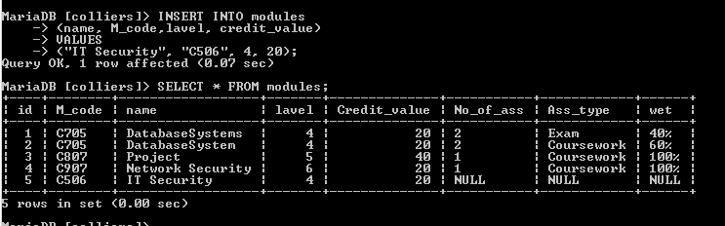

Figure 24: insert new modules databases.

**14. Insert a new company.**

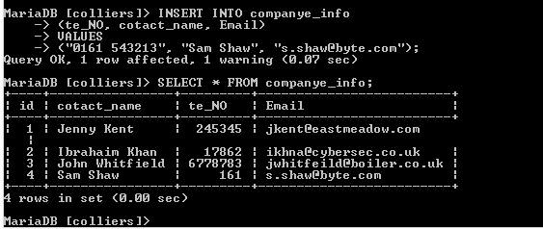

Figure 25: it is inserting into a new company databases.

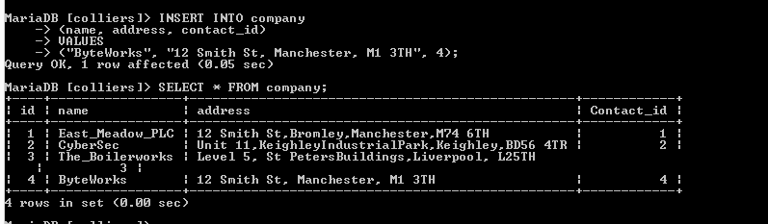

15. Update the course level.

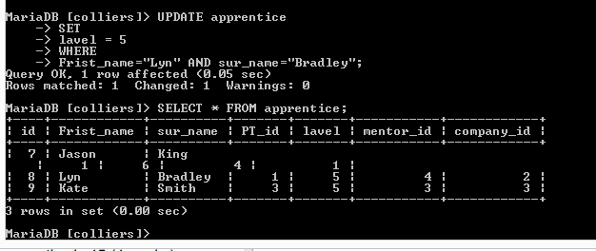

Figure 26 : update the course level for Bradley.

16.delet the module network "network security".

Figure 27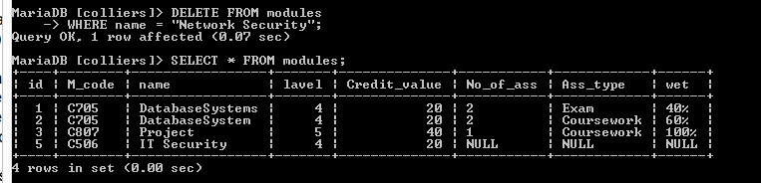

Figure 28: delete modules "network security"

**Task 3**

**Assessment**

This task is to an assessment of how the work you have done has met the requirements of Colliers Work Based Learning System. This company until now use paper and hard copy for manage records on customer, employee, and teacher/trainer. Use of the database that I have made will let the company act with more function and ability as maintaining company will be easier than before. The amount of time a use of database can save it highly higher than use of paper records.

All records will be store in databases and can be access when query is made. Data can also input into database. Collier’s will need a table to hold record of learner’s admission and the number of learners in admitted. Which designated pathway the learner is admit. And also know which company a learner is coming from. Tutor information will also need to be normalized as the table will have to be related to learner. How learner and tutor will meet in place will also normalized and related.

Our number one stepping is to creation of normalization of database. This will have data organize in database and allow us to relate table to each other. After normalization finish, we start to make an Entity Relationship Diagram or ERD which have all attribute of tables of learner, tutor, time, meeting place information, etc. and we will relate them to one and another. For SQL queries we will have use xampp. Like up there, I have make an Entity Relationship Diagram and match all fields of tables.

Now I have make sure that all relationship and condition have are met like; apprentice entitled to one visit from mentor/tutor, number of contact point company have on employee which is apprentice, core elements of apprenticeship, etc. Here is my decisions and their justification. I have met the requirements of the assignment and have proved the use of completed requirements through screenshots of every task information and ERD diagram. I have written my report with appropriate snapshots to avoid plagiarism check fails.